Effects of Water Pollution on Plant DiversityStudent X

SCI 2XX: Environmental Science

Instructor: XXXXXXXXX

September 22, XXXX

**Effects of Water Pollution on Plant Diversity**

Water pollution can have severely negative effects on biodiversity and ecosystems, particularly on plant populations. In many cases, these pollutants are introduced to the environment through everyday human activity. In this experiment, you will contaminate several water samples, as well as purify a water sample. You will then evaluate the effects of water pollution and purification on the biodiversity of wildflowers.

|  |  |
| --- | --- |
| **Table 1: Water Observations (smell, color, etc.)** | |
| **Beaker** | **Observations** |
| **1** | **Smells like nothing very clear** |
| **2** | **The oil smells like nothing and didn’t mix very well either** |
| **3** | **Vinegar is strong and it mixes well and was very clear** |
| **4** | **Smells like detergent and its very soapy still clear** |
| **5** | **Some of the soil escaped through the cheese cloth, very dirty. Gave 50 ML of water** |
| **6** | **A darker brown as far as the water goes 90 ML smelled like soil** |
| **7** | **Smelled like soil very light brown is 80 ML and it smells like detergent. I can’t smell the soil at all** |
| **8** | **A redish brown soil at 95 ML has a soil smell to it.** |

**Analysis of Results**

**What effects did each of the contaminants have on the water in the experiment? Use Table 1 for reference.**

For the most part it turned it another color and it made it either soapy or a clear filmy color.

**2. What kinds of human activities could cause oil, acids, and detergents to contaminate the water supply?**

Cooking food, washing clothes, another science experiment.

**3. What are the differences in color, smell, visibility, etc. between the “contaminated” water and the “treated” water?**

Contaminated water looks dirty treated water smells like bleach and is supposed to be drinkable.

**4. From the introduction to Lab 2, you know that there are typically five steps involved in the water treatment process. Identify the processes (e.g., coagulation) that were used in this lab and describe how they were performed.**

Collecting the water, testing, and taking samples. Treating the water, testing the acidic levels to make sure it can be used.

**5. Develop a hypothesis regarding how using contaminated or purified water might affect plant biodiversity. Which pot do you believe will contain the greatest biodiversity (greatest number of species)? Why?**

The contaminated water is what’s happening to our biosphere. All of this water that has rusted our pipes or hurting our environment. The tap water will have the greatest biodiversity. If the tap water is meant to mimic natural water, the plants will grow better.

|  |  |  |  |
| --- | --- | --- | --- |
| **Table 2: Number of Plant Species Present in the Pots** | | | |
| **Species Observed** | **Tap Water** | **Contaminated Water** | **Purified Water** |
| **Zinnia** | **N** | **N** | **N** |
| **Marigold** | **N** | **N** | **N** |
| **Morning Glory** | **Y** | **Y** | **Y** |
| **Cosmos** | **Y** | **Y** | **Y** |
| **Ryegrass** | **Y** | **N** | **N** |
| **Total Number of Species in Pot:** | **3** | **2** | **2** |

Day 1

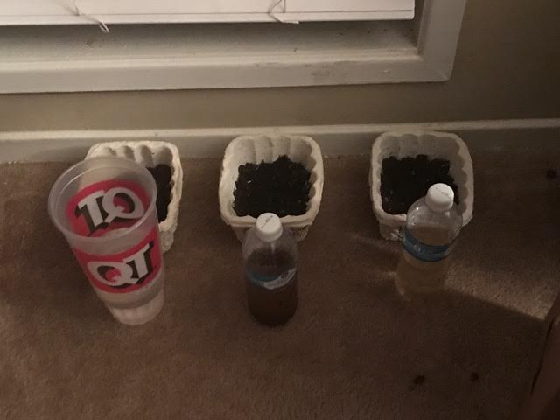

Day 2

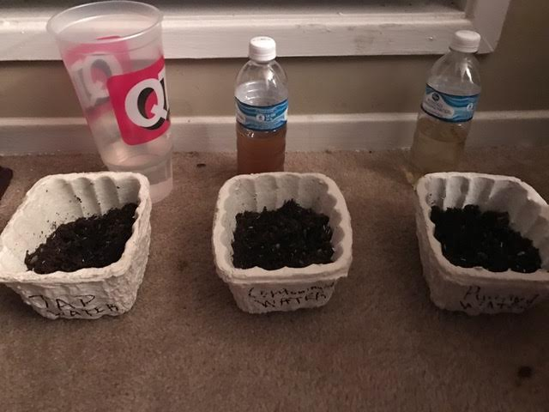

Day 3

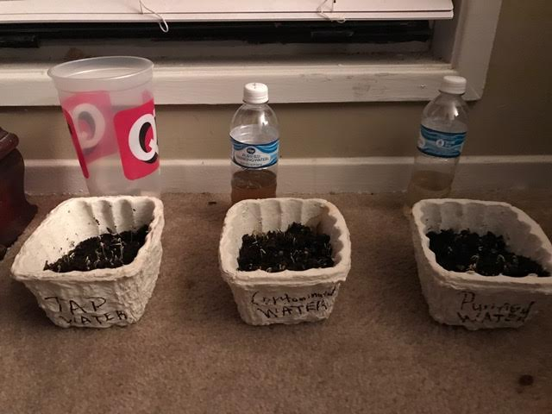

Day 4

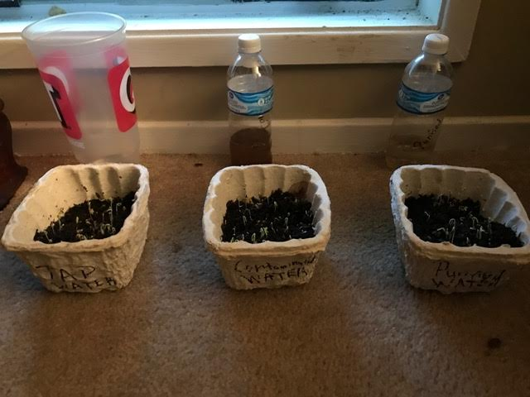

Day 5

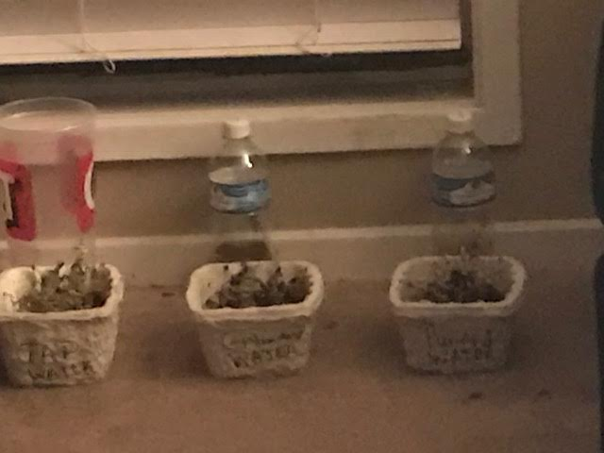

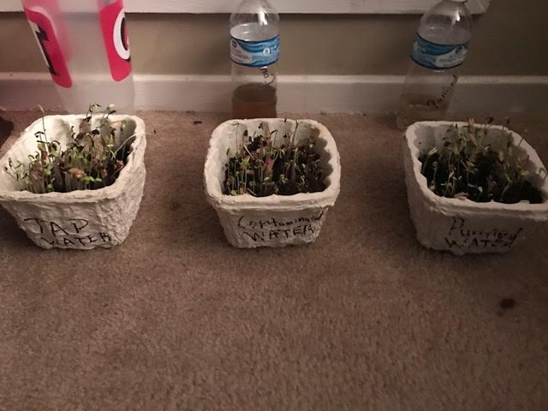

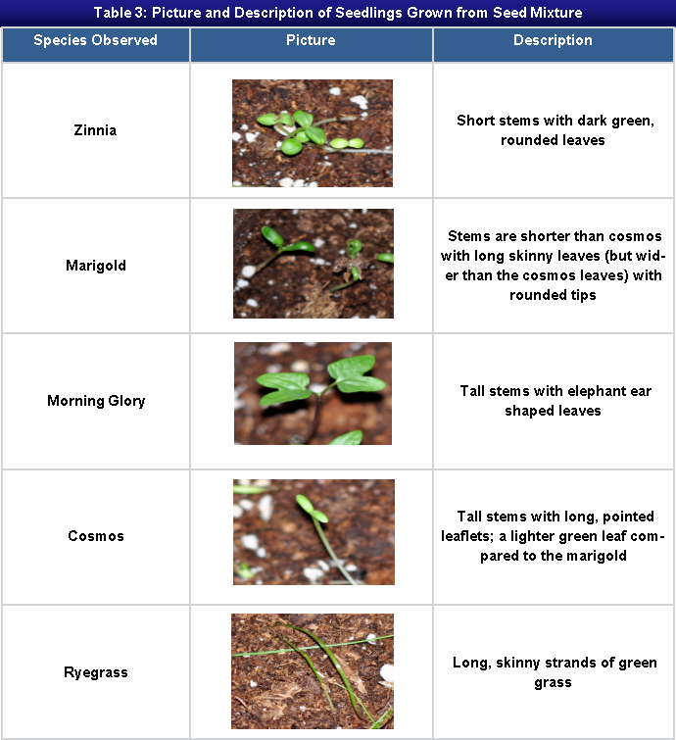

1. **Based on the results of your experiment, would you reject or accept the hypothesis that you produced in question 5? Explain how you determined this.**

I would accept my hypotheses because the tap water did show more growth, and it’s because the water hasn’t been altered.

1. **Alum contains aluminum. Research the effects of aluminum on plants by finding a scholarly source online. Does your research provide any insight into your results? Discuss your findings as they relate to the results of your experiment.**

Aluminum is technically a natural element which will keep a thriving plant growing.

1. **Imagine that each pot was a sample you found in a group of wildflowers. Based on the diversity of flowers in each pot, would you consider the ecosystem to be healthy? Why or why not?**

The ecosystem with tap water and contaminated water was the healthiest because it hasn’t been filtered.

1. **How does biodiversity contribute to the overall health of an ecosystem? Provide specific examples and utilize at least one scholarly resource to back your answer.**

When one thing leaves the Amazon, it’s Coral reef disputes the entire balance.

1. **Rank the following three scenarios in terms of having the most to least biodiversity and provide your rationale for these rankings.**

* **A vacant lot behind a car repair facility.**
* **A designated national wilderness area.**
* **A grassy strip along the highway.**

1 the grassy strip has had a road built along the wilderness. It has been exposed therefore it has the least biodiversity.

2 designated wilderness area has been prepped and altered to keep only those designated to be a part of it. It has limited.

3 Has had any activity or human interaction so it would have the most biodiversity over time.

**References**

* Turk, J., & Bensel, T. (2014).[*Contemporary environmental issues*](http://outboundsso.next.ecollege.com/default/launch.ed?ssoType=CDMS&redirectUrl=https://content.ashford.edu/ssologin?bookcode=AUSCI207.14.2) (2nd ed.) [Electronic version]. San Diego, CA: Bridgepoint Education, Inc.
* Walter H. Adey (2000) Ecosystems and human health: Biodiversity Health (Issue 4 Vol. 6 Pg. 227-236)